E-Commerce Sales Analysis Report

## PROJECT OVERVIEW
This project analyzes an E-Commerce Sales dataset to uncover valuable business insights related to sales performance, profitability, customer purchasing behaviour, product performance and regional trends. The project follows a complete analysis workflow including data cleaning, SQL analysis, Python exploratory data analysis (EDA) and an interactive dashboard with KPIs.
---
## OBJECTIVES
- Clean and prepare raw e-commerce sales data.
- Analyse sales and profit performance across different regions and product categories.
- Identify top-performing products and customers data.
- Evaluate payment methods and discount patterns.
- Build an interactive dashboard to support business decision-making.
---
## TOOLS AND TECHNOLOGIES
- Google Sheets – Data Cleaning
- SQL (SQL Server) – Business Analysis
- Python (Pandas and matplotlib) – EDA
- PowerBI- Interactive Dashboard
---

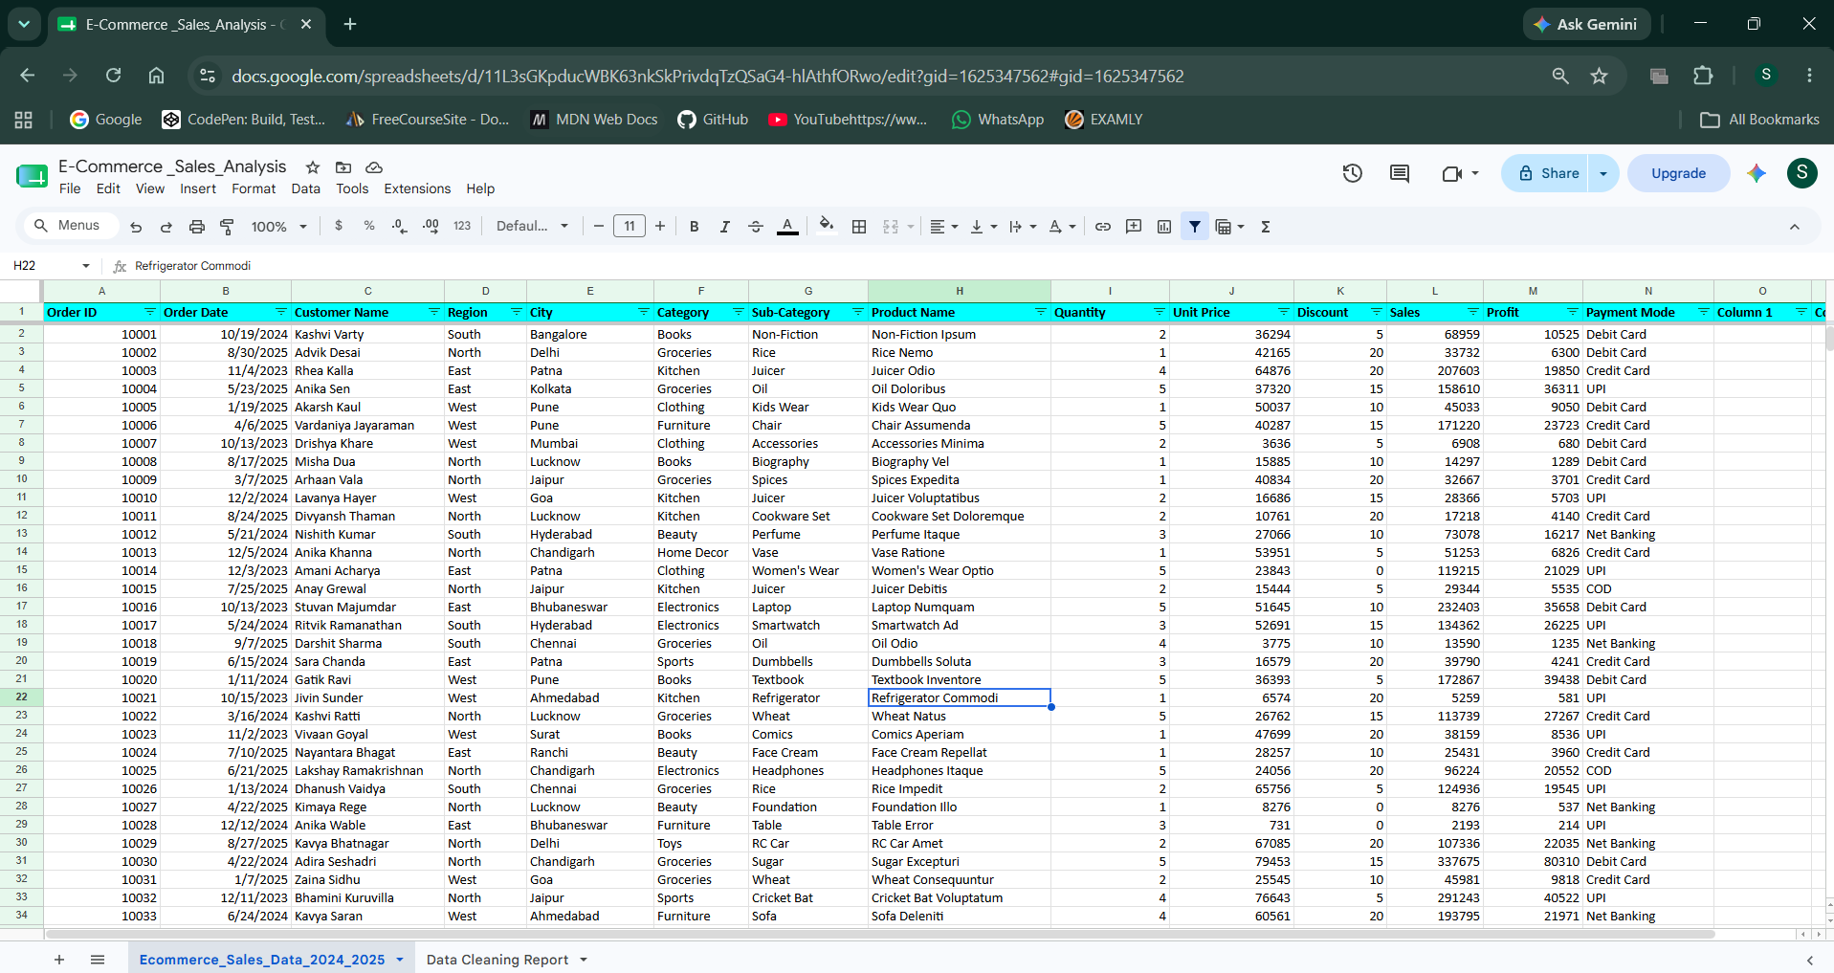
## DATASET INFORMATION

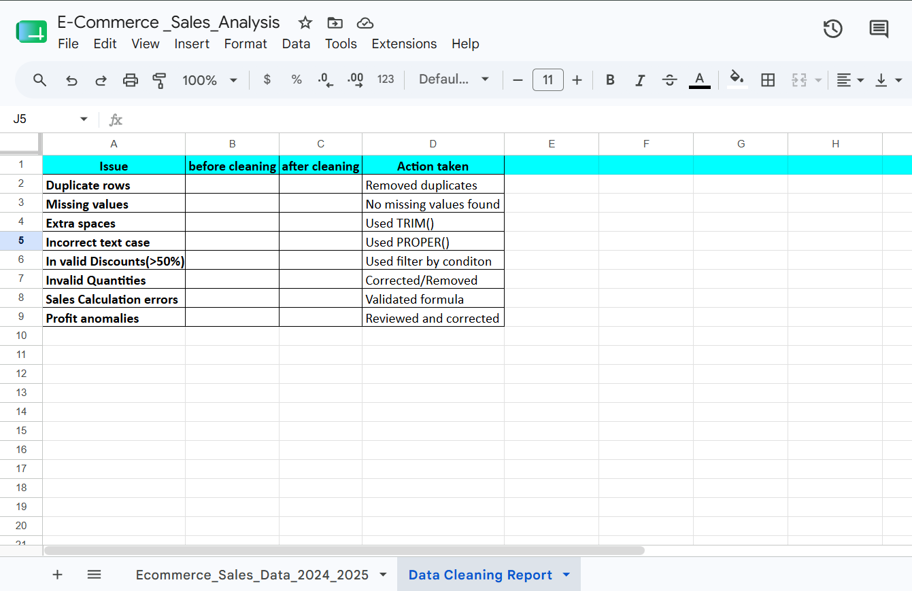
## DATA CLEANING REPORT

---

## DATA CLEANING (GOOGLE SHEETS)
### The following cleaning steps were performed:
- Removed duplicate records
- Checked and handled missing values using conditional formatting
- Corrected invalid discounts (50%)
- Standardized text formatting
- Formatted date and currency columns
- Verified Sales calculations
- Verified Profit values
---
## SQL (BUSINESS ANALYSIS)
### Business questions answered:
- Which region generated the highest revenue?
- Which city has the highest average order value?
- Top 10 products by profit
- Top 5 subcategories by revenue
- Payment method generating the highest revenue
- Products with above average discounts
- Monthly sales trend
- Average profit margin by category
- Products sold above average quantity
- Product ranking by profit
- Running total of monthly sales (Cumulative sales)
- Sales contribution (%) by category
---
### SQL CONCEPTS USED
- GROUP BY()
- ORDER BY()
- TOP
- Aggregate Function
- CASE WHEN()
- Subqueries
- Window Functions – RANK(), OVER()
- Running totals
---
## PYTHON EXPLORATORY DATA ANALYSIS
### Analysis performed:
- Dataset overview
- Missing value analysis
- Sales distribution
- Profit distribution
- Correlation between discount and profit
- Top-selling products
- Average discount by category
- Payment mode distribution
- Profit outlier detection

### Python Libraries
- Pandas
- Matplotlib
---
## POWER BI DASHBOARD
### KPI Cards
- Total Sales
- Total Profit
- Total orders
- Profit Margin %
- Average Discount

### Dashboard Visuals
- Monthly Sales trend
- Sales by Category
- Profit by Sub-category
- Top 10 City by Profit
- Sales by Payment Method
- Sales by Region

### Interactive Filters
- Region
- Month
- Category
---

## Key Insights
- Total sales reached ₹534M, generating ₹80M in total profit, resulting in an overall profit margin of 14.94%.
- North was the highest-performing region, contributing ₹144M (26.9%) of total sales, while South contributed the lowest at ₹123M (23.09%).
- The top two regions, North and East, generated ₹280M, accounting for approximately 52.35% of total sales, showing that more than half of revenue came from these regions.
- Payment methods were relatively evenly distributed. Net Banking had the highest share at 20.89% (₹111M), while UPI had the lowest at 19.10% (₹102M) — only a 1.79 percentage-point difference.
- The business recorded approximately 5K orders, with an average discount of 10.05%, while maintaining a 14.94% profit margin.
- Sofa and Lamp were the highest-profit sub-categories, each generating more than ₹2M in profit, indicating their strong contribution to profitability.
- Monthly sales showed noticeable fluctuations, with the highest monthly sales at approximately ₹51M and the lowest around ₹40M, representing a difference of roughly ₹11M (27.5%)

## BUSINESS RECOMMENDATION
- Focus on high-margin products and review low-margin products to improve overall profitability.
- Prioritize marketing, inventory and promotional campaigns in North and East while identifying opportunities to improve weaker regions.
- Continue supporting popular digital payment methods and use targeted offers to encourage repeat purchases through preferred payment channels.
- Review discount levels by product and category to ensure discounts increase sales without unnecessarily reducing profit margins.
- Maintain sufficient inventory and promote these high-profit sub-categories to maximize their contribution to overall profit.
- Investigate the causes of monthly fluctuations and plan inventory and marketing campaigns around high-demand periods.

## CONCLUSION
### This project helped to find out the ecommerce company that globally operates what problems were facing and how to solve those issues by taking actionable ways to support business decision making. These issues are common in many ecommerce companies. Simple and actionable strategies can contribute to perform effectively.
---
Author: Sneha Sharma

